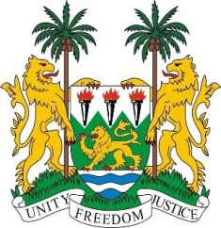
SIERRA LEONE

27th Session of the UPR

PHILIPPINES

8 May 2017

Mr President,

Sierra Leone welcomes the distinguished delegation from the Philippines to this review cycle and thanks them for today’s presentation.

My delegation commends the Government of the Philippines for the sustained efforts aimed at improving the lives of its people, notably through the Sustainable Livelihood Program, various legislative amendments to address social inequalities and discrimination, as well as by providing in 2016, health and education grants to 4.39 million of its poor citizens and its comprehensive support to its migrants abroad.

My delegation notes, with satisfaction, the concerted efforts to address the rights of women, including through the Magna Carta Act for Women and congratulates the Philippines for coming seventh in the World Economic Forum Gender Gap Index.

Recommendations:

- Ratify the ICPPED.
- Thoroughly investigate and prosecute killings by private armies and vigilantes responsible for unsanctioned activities during the government’s anti-drug campaign.
- Strengthen preventative cross-border anti-trafficking strategies and their implementation.

Finally, Sierra Leone wishes Philippines every success in this third review cycle.

Thank you, Mr President.

